YOSEMITE NATIONAL PARK VIRTUAL FIELD TRIP
FIELD GUIDE
Tracy Donelli

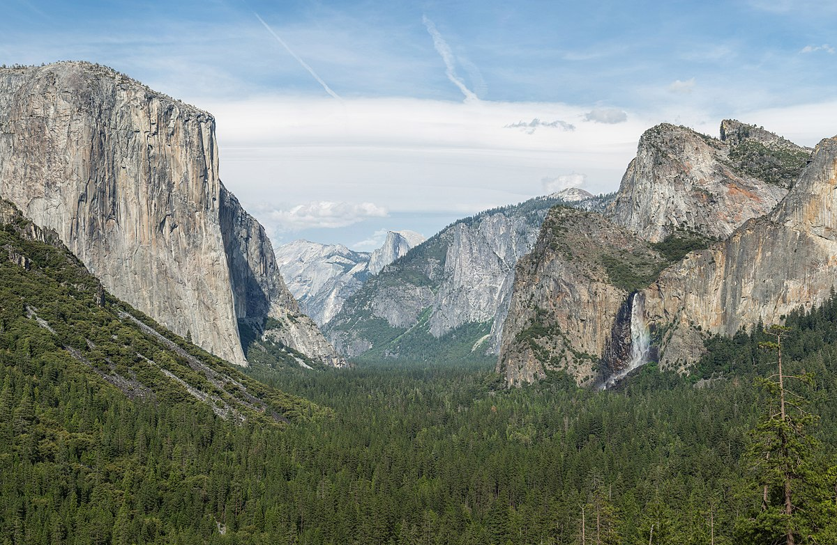
Photo Credited to: https://en.wikipedia.org/wiki/Yosemite_National_Park

Visit www.yosemitevirtualfieldtrip.net and follow this field guide to complete the trip.

The site should open on the “Home” screen.
Read through the Home screen to find out learning objectives, supplies needed to complete the field trip, prior background education required, duration of the trip, use in the classroom, and how to obtain more information on Yosemite National Park. This field guide is designed to assist college level students in walking through this virtual field trip.

Yosemite National Park is located in the Western Sierra Nevada, in central California. The park is 1,169 square miles. The park is known for its breathtaking geologic features, large sequoia trees, glaciated landscapes and many other beautiful sites to see.
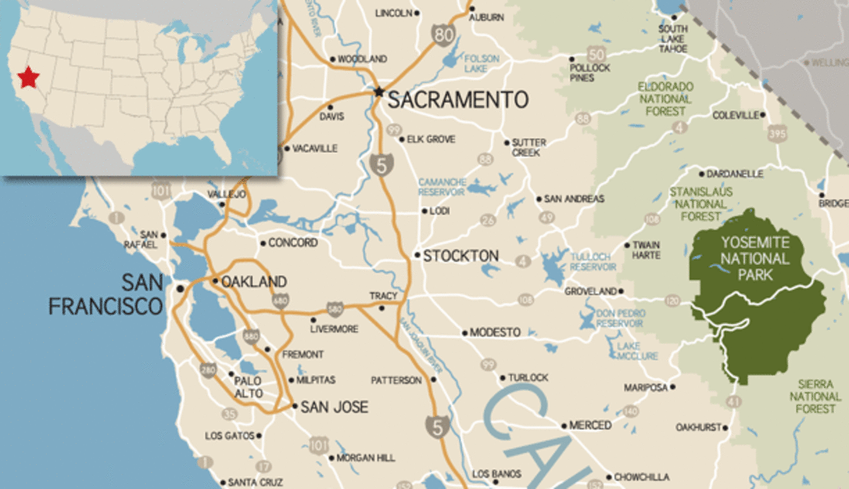
Photo credited to: https://www.myyosemitepark.com/park/yosemite-national-park

Once you scroll to the bottom of the Home page, click the “Begin” button. This will take you to the Geologic Time page.

This page will take you through Yosemite’s geologic history. In order to fully grasp the geologic phenomena that occur here, one must understand the formation process.

Read through this page up until the “Earth’s History” video. Then answer question 1 below.

Question 1:
What is the difference between relative dating and numeric dating?

Now watch the “Earth History” video. Then answer questions 2-3 below.

The Earth is 4.56 billion years old. It is tough for us to comprehend how long that really is. That video should have helped put things into perspective a bit.

Question 2:
How much geologic time was represented by one inch on the football field from the video?

Question 3:
How long ago did oxygen start building up in Earth’s atmosphere?

Continue reading the rest of this page. Upon completion, answer questions 4-5 below.

Yosemite’s formation lasted for a span of millions of years. This consisted of magma intruding into the Earth’s crust, and a process of melting and cooling. These large plutons, which make up Yosemite National Park, eventually came to the Earth’s surface after many years of uplift and erosion.

Question 4:
When did Yosemite’s formation begin?

Question 5:
What are the 5 steps of incremental growth in Yosemite?

Once you finish reading this page click the “Continue” button to proceed to the Mineralogy portion of the field trip.

Mineralogy determines different characteristics about the rocks found in Yosemite (or anywhere, really). Something we will discuss on this field trip is the distinction between mafic, felsic, and intermediate minerals and rocks. Felsic minerals are comprised of predominantly silica and oxygen. In addition to that elements such as sodium, potassium, and calcium can be found in felsic minerals. Mafic minerals contain these elements as well; however, they contain a notable amount of iron and magnesium. Intermediate mineral composition is roughly 50/50 mafic and felsic. Rocks are considered either mafic, felsic, or intermediate depending upon what minerals they are made up of.

Read until you see the question provided to classify whether the rock presented is felsic, intermediate, or mafic and answer. Then answer questions 6-7 below.

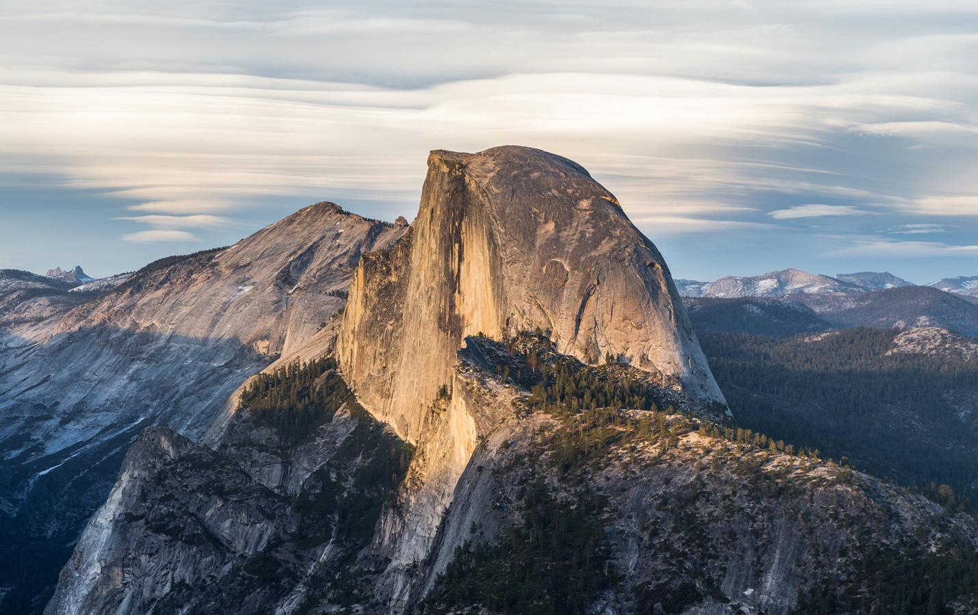
Half Dome in Yosemite. Photo credited to: https://en.wikipedia.org/wiki/Half_Dome

Question 6:
How did the rocks form in Yosemite? What type of rocks are they? Metamorphic, Igneous, or Sedimentary?

Question 7:
Look at the second crystallization GIF. List the 6 main minerals that can be found in this rock of Yosemite in the order in which they crystallized in.

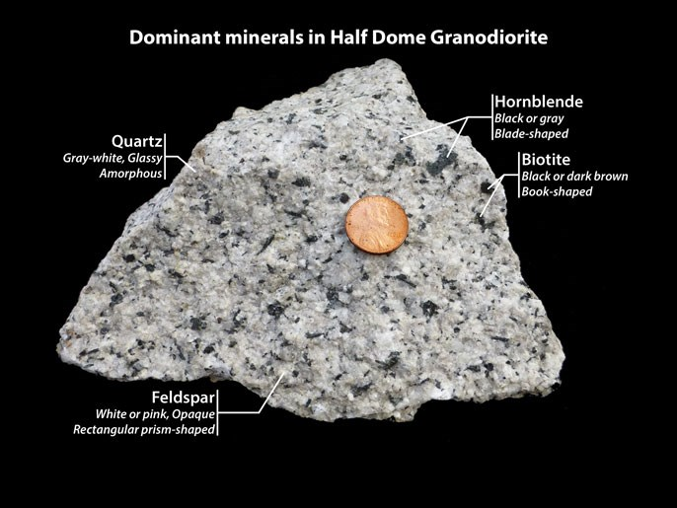
Photo credited to: https://www.nps.gov/yose/learn/nature/granite.htm

Continue reading through this page. Upon completion, click the “Continue” button to proceed to the “Magmatic Features: Dikes” portion of the field trip.

Magmatic dikes form by flowing magma filling in a fracture of a pre-existing rock. Sedimentary dikes form when sediment fills a fracture of a pre-existing. The dikes we see in Yosemite are magmatic dikes.

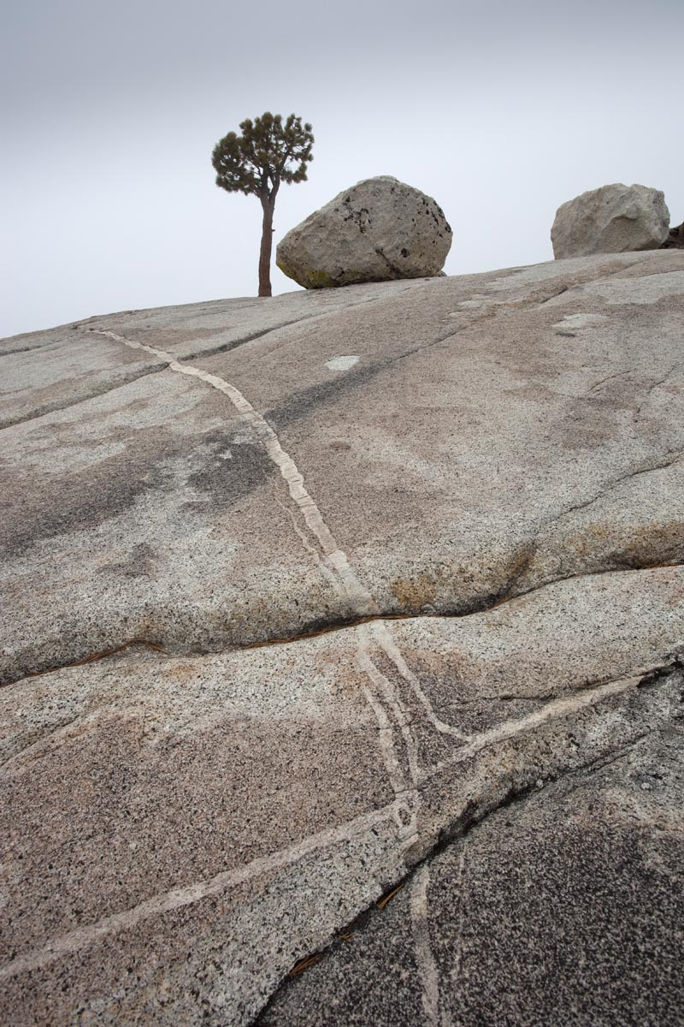
Photo credited to: http://marlimillerphoto.com/111118-16.html

Read up until you see the “Dikes” video. Watch the video for more detail on the formation of dikes. Then answer question 8 below.

Question 8:
How can you spot a dike in Yosemite?

Continue reading until you reach the Test Your Knowledge portion of the page. Then answer questions 9-11 on the next page.
Question 9:
Explain the Law of Cross-Cutting Relationships in relation to dikes found in Yosemite. What does this tell us about relative dating?

Question 10:
True or False? Dikes can occur in many different thicknesses.

Question 11:
Sketch a dike.

Complete the Test Your Knowledge portion of this page.

Upon completion, click the “Continue” button to proceed to the Magmatic Features: Stoping portion of the field trip.

Stoping is another magmatic process that occurred during the formation of Yosemite that resulted in stoped blocks. In this field trip, stoping is explained through a common phenomenon we see in our daily lives.

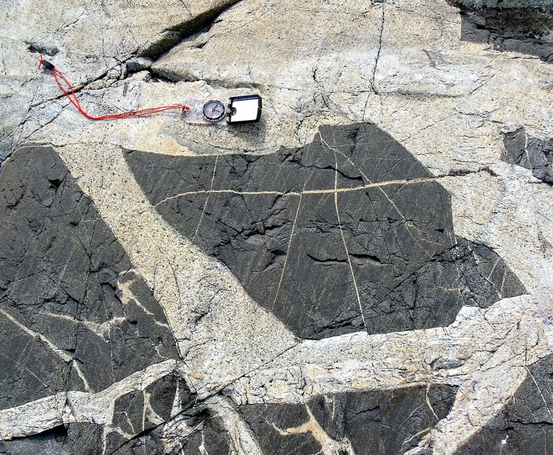
Photo credited to: https://en.wikipedia.org/wiki/Stoping_(geology)

Read the first four paragraphs and listen to the audio recording provided. Guess what the sound is before revealing the answer.

Ice expands and cracks in a glass when water is added to it. Similarly, stoping occurs when hot magma interacts with cooler host rock. The expansion and breakage are a result of the drastic temperature changes.

Watch the “Stoping” video.

Continue reading through and stop once you reach the Test Your Knowledge portion of the page. Then answer questions 12-15 below.

Question 12:
Explain the Principle of Inclusions and how it relates to stoped blocks in Yosemite.

Question 13:
Why are stoped blocks difficult to find in Yosemite?

Question 14:
True or False? Stoped blocks are always larger than 1 meter in size.

Question 15:
Sketch and label a stoped block within a host rock.

Complete the Test Your Knowledge portion of this page.

Upon completion, click the “Continue” button to proceed to the Magmatic Features: Enclaves portion of the field trip.

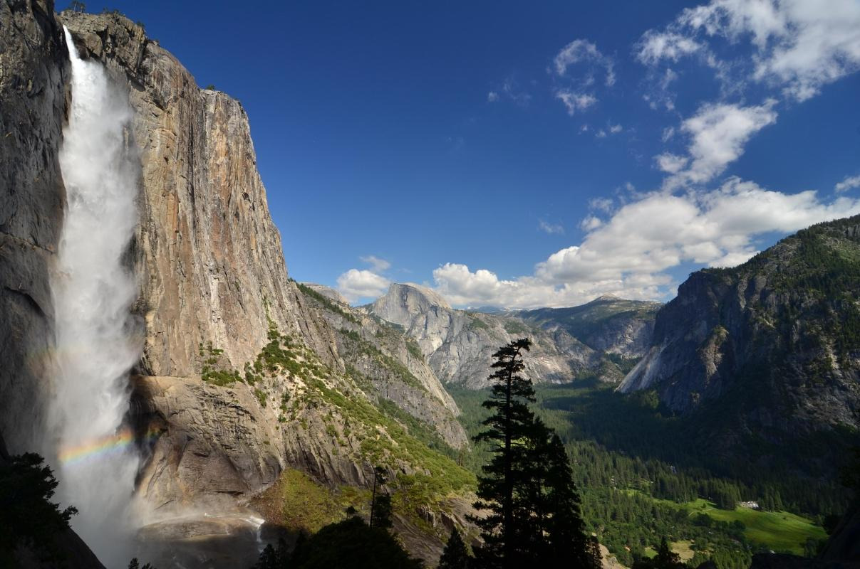
Photo credited to: https://www.viator.com/Yosemite-National-Park-attractions/Yosemite-Falls/d5265-a11036

Read through until the Oil and Water experiment.

Enclaves are a certain type of rock surrounded by a host rock with differing composition. They can be identified by their change in color. They are similar to dikes but look and form differently.

Read through the Supplies and Directions portion of the Oil and Water experiment. Then answer question 14.

Question 14:
Before watching the video – Draw a quick sketch to hypothesize what the solution will look like once the oil and water are combined.

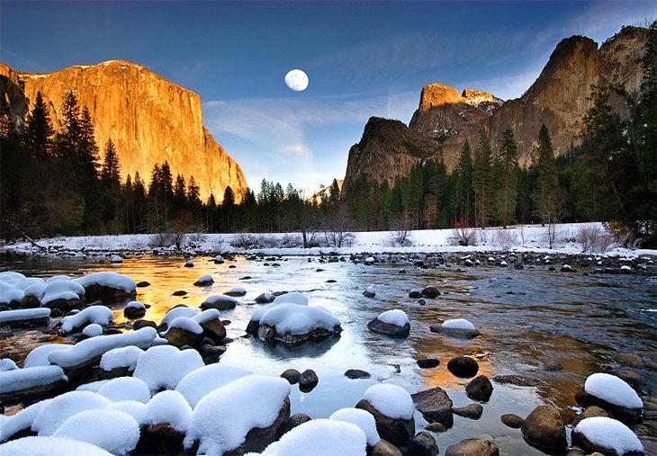
Photo credited to: https://www.planetware.com/california/best-time-to-visit-yosemite-national-park-ca-us-ca-549.htm

Now if you have the materials, follow along the Oil and Water experiment, or you can simply watch the video. Continue reading through until you reach the Test Your Knowledge portion. Then answer questions 15-18 below.

Question 15:
After watching the video – Draw a quick sketch of what the solution looked like after she mixed the oil and water together.

Question 16:
What is viscosity and how does it relate to the formation of enclaves?
Note: Refer to the oil and water experiment.

Question 17:
True or False? Felsic magmas have low viscosity.

Question 18:
How can you tell the difference between a dike and an enclave?

Complete the Test Your Knowledge portion.

Upon completion, click the “Finish” button. You have now completed the Yosemite National Park Virtual Field Trip!

Flip to the next page to learn about an interesting phenomenon that people travel from all over the world to see in Yosemite National Park.

YOSEMITE NATIONAL PARK - FIREFALL

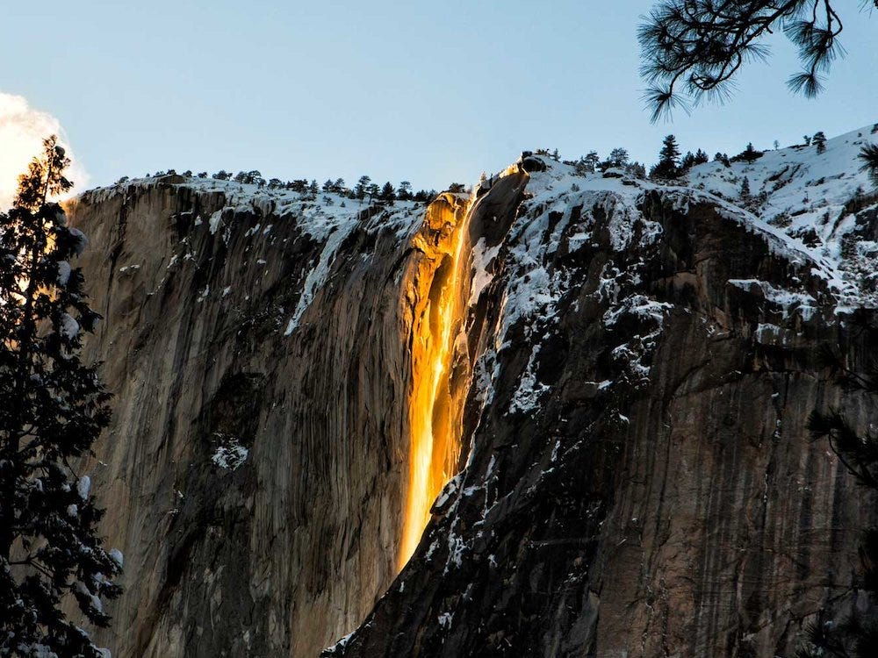
Photo credited to: https://www.insider.com/yosemite-firefall-two-weeks-february-how-to-see-2020-1

This visual trickery is Horsetail Falls waterfall in Yosemite National Park. Lighting and weather conditions must be perfect in order to see this optical illusion of what looks like a “firefall”. These conditions include adequate snow accumulation, temperatures warm enough to melt the snow, and the sun needs to be in just the right spot seasonally. This typically occurs for a few weeks during the month of February. A waterfall that appears to be made of lava seemed like a fitting ending to this magmatic field trip.

